EXP NO 9. Create a Virtual Hard Disk and allocate the storage using VM ware
DATE:
AIM:
To create a virtual hard disk and allocate the storage using Oracle VirtualBox (Type-2 Hypervisor).
PROCEDURE:
STEP 1: Open Oracle VirtualBox and select the virtual machine where you want to add a new hard disk.
STEP 2: Right-click on the VM and select Settings.
STEP 3: Go to Storage → Click on the Controller (SATA/SCSI/IDE) → Click Add Hard Disk.
STEP 4: In the wizard, select Create New Disk.
STEP 5: Choose VDI (VirtualBox Disk Image) as the disk type and click Next.
STEP 6: Select Dynamically allocated or Fixed size based on requirement.
STEP 7: Specify the disk size (e.g., 2 GB) → Enter a file name → Click Create.
STEP 8: The new virtual hard disk will now be added and allocated to the selected VM.
DESIGN:
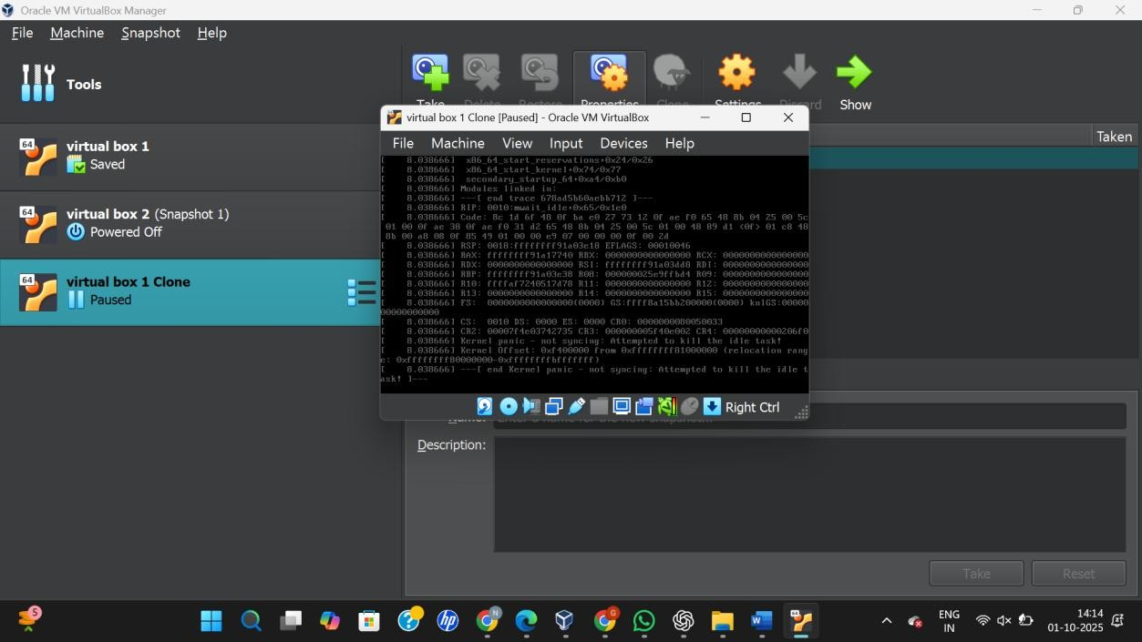
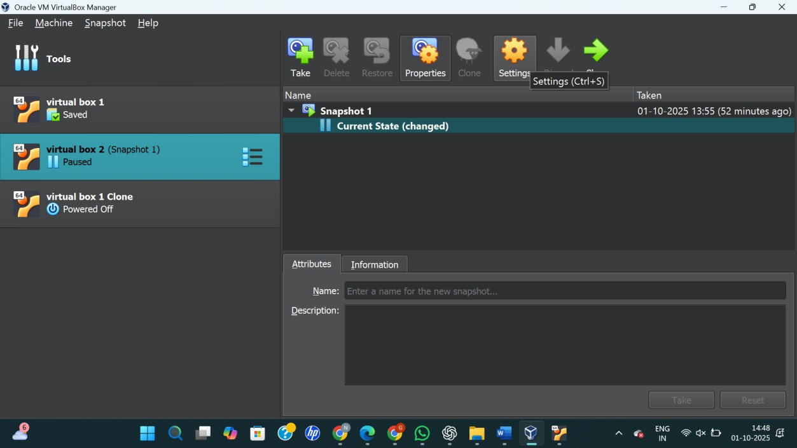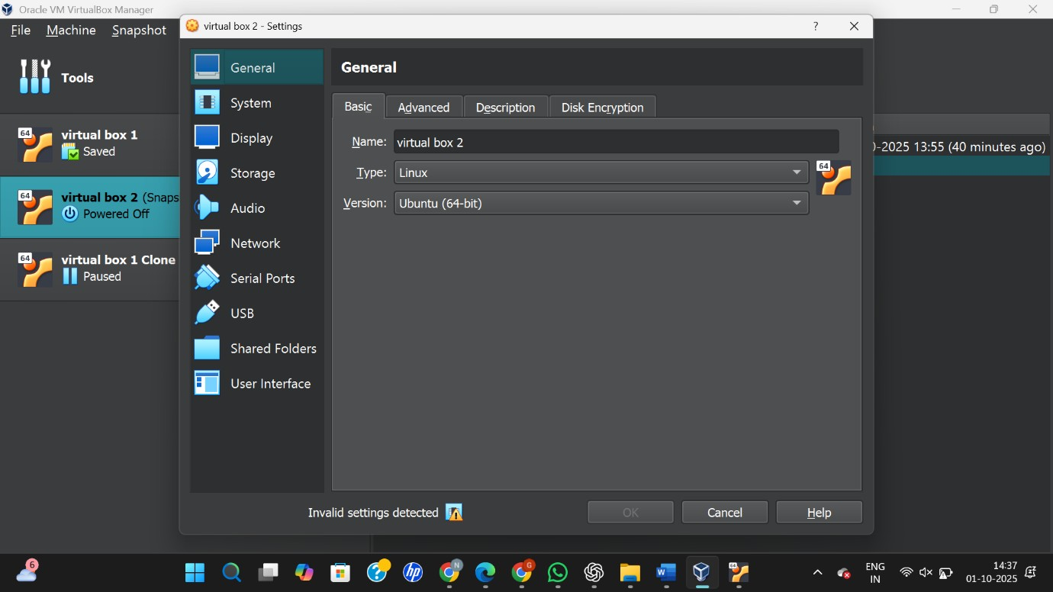
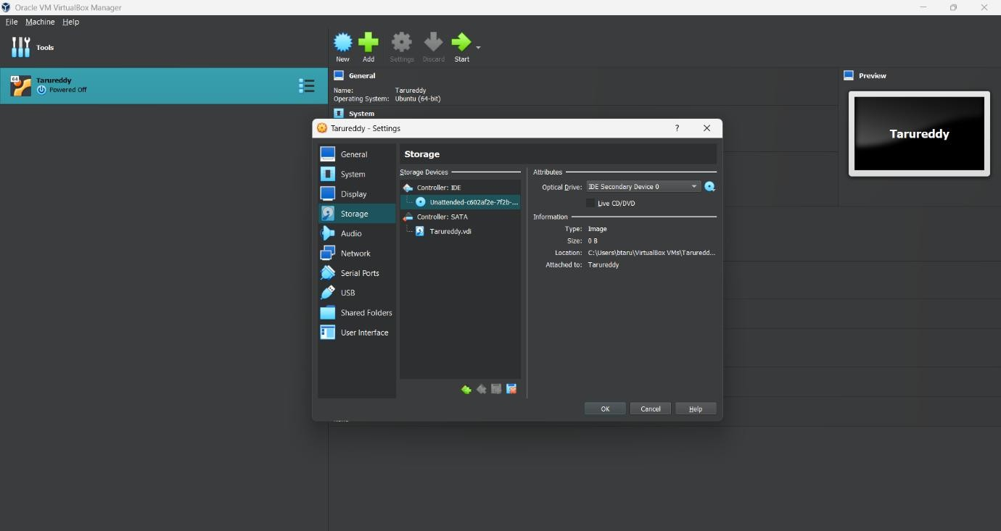

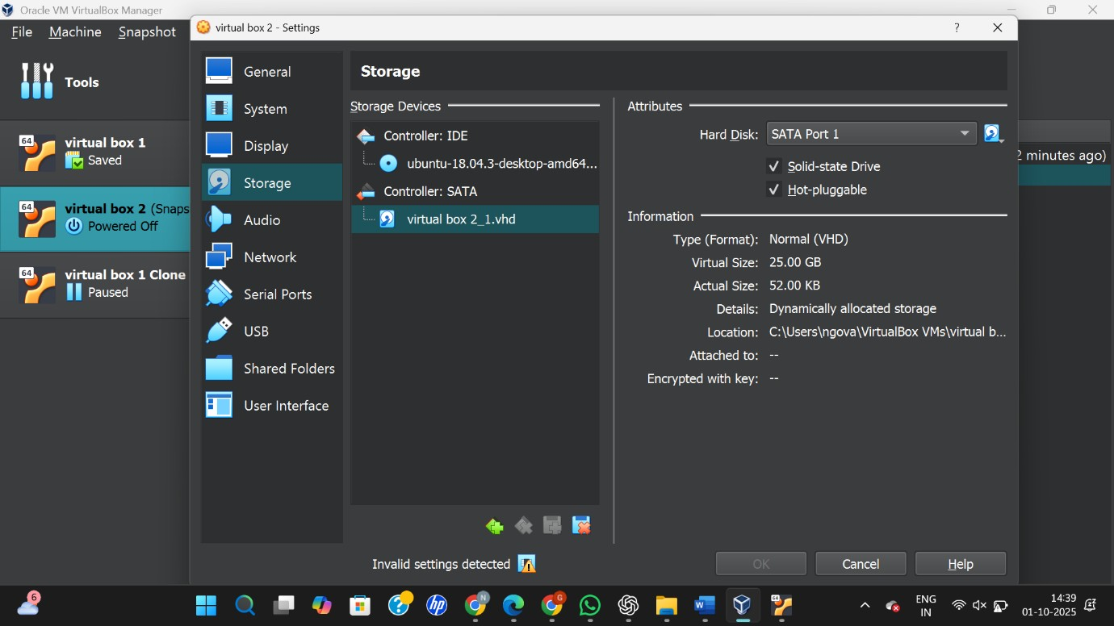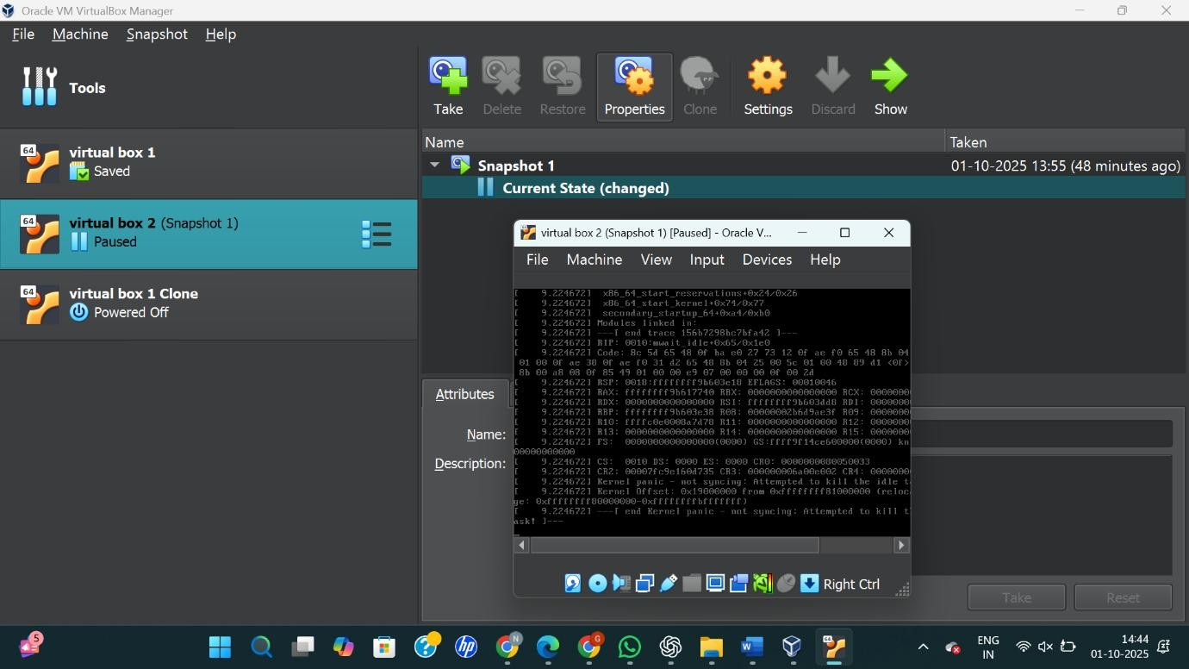

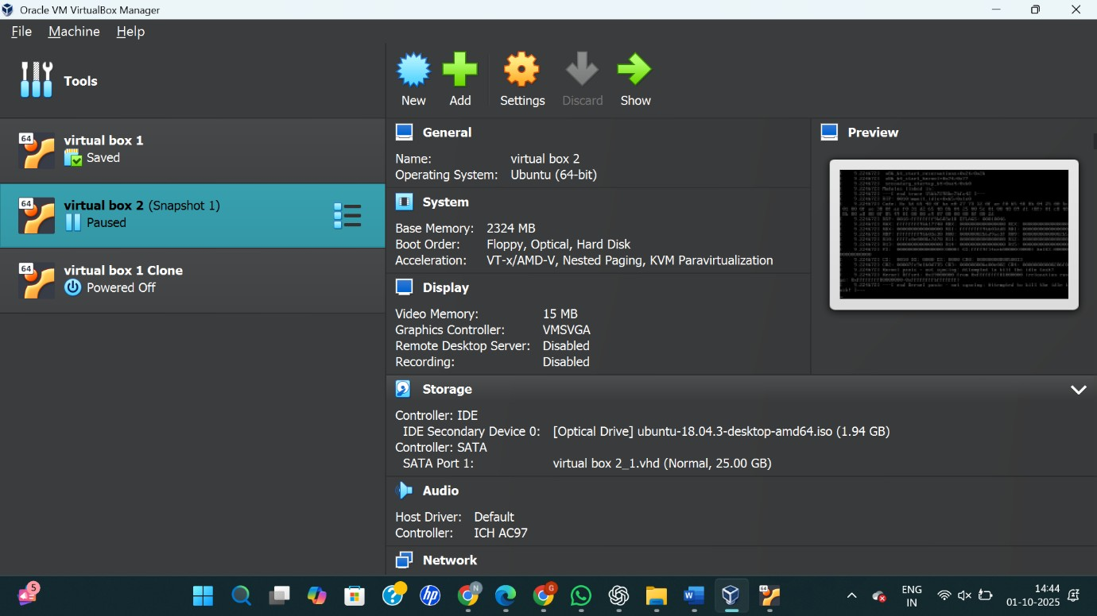
RESULT:
A virtual hard disk was successfully created and allocated to the virtual machine using Oracle VirtualBox.

